**Report of Seminar 8**

Please propose **2-3** realization approaches according to the required functions assigned to each group. It is asked to:

* Take into account the practical **components parameters** and **control scheme**;
* Discuss the **differences** between the proposals that you provide;
* Select the optimal one among your proposals and state your reason;
* Simulation and analysis on operating principle.

**Group 6:** You are assigned to design a DC-DC Switching Mode Power Supply. The input voltage should be set as 12Vdc for each phase, and the output voltage and current should be set as 220Vdc/30A. You should also pay attention that the peak-to-peak value of the output voltage ripple should not be larger than 5% of nominal output voltage.

1. **Isolated DC/ DC boost converter**

**Model:**

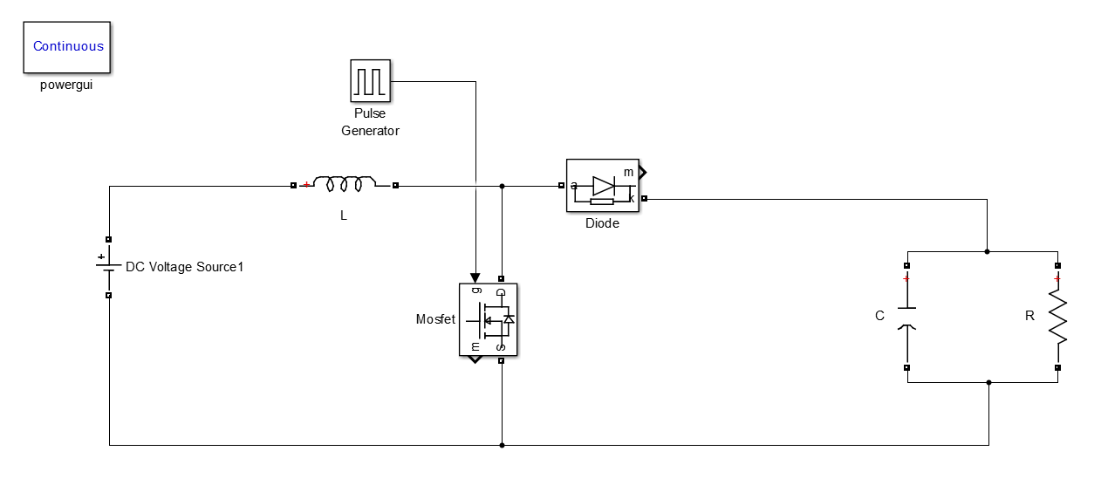

As we can see,it’s a boost circuit and BOOST circuit is a DC-DC chopper circuit. It can be the output voltage is higher than the input voltage. Which can be divided into a process of charging and discharging processes.

**Calculation and parameters setting:**

1. For the requirements given above, we made a calculation as follow to find out the duty cycle.

$\frac{U_{0}}{U_{S}}=\frac{220}{12}=\frac{1}{1-D_{C}}$

DC=0.94545454545

1. Then we calculated for the value of the inductance.

The resistance is assumed as 

the frequency is assumed as 40kHz.

$L_{C}=\frac{R}{2}D_{C}{\left(1-D_{C}\right)}^{2}T_{S}$ = $\frac{10}{2}×0.94545{\left(1-0.94545\right)}^{2}×\frac{1}{40000}$

$$L_{C}=0.25785μH$$

We choose 1.2 LC as our practical value of inductance.



1. The ripple wave

ΔU0=

So we will know

C= $\frac{V_{0}D_{C}T_{S}}{R{ΔU}_{0}}$ = $\frac{220×0.94545}{7.333×0.05×220×40000}$

C $=64.465μF$

In accordance with convention, put some margin to the C and we can get



1. Some necessary settings

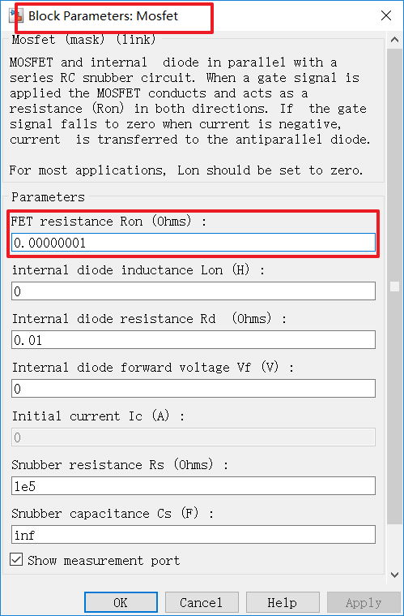 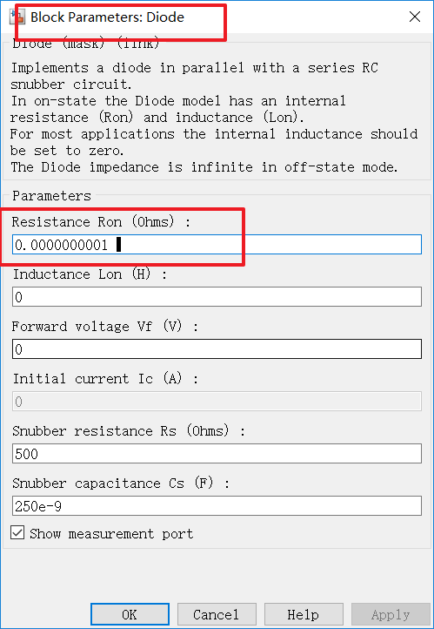

Resistance of the two switch can be very ideal and through this way, the waveform of the current can be more beautiful.

**Simulation:**

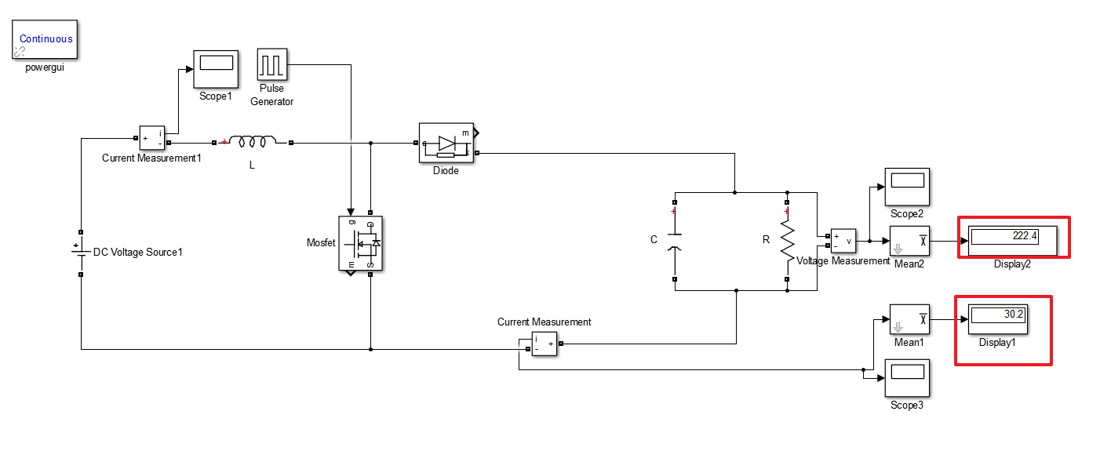



Through this way, we can easily get the result of the aim voltage and current.

**Waveforms**

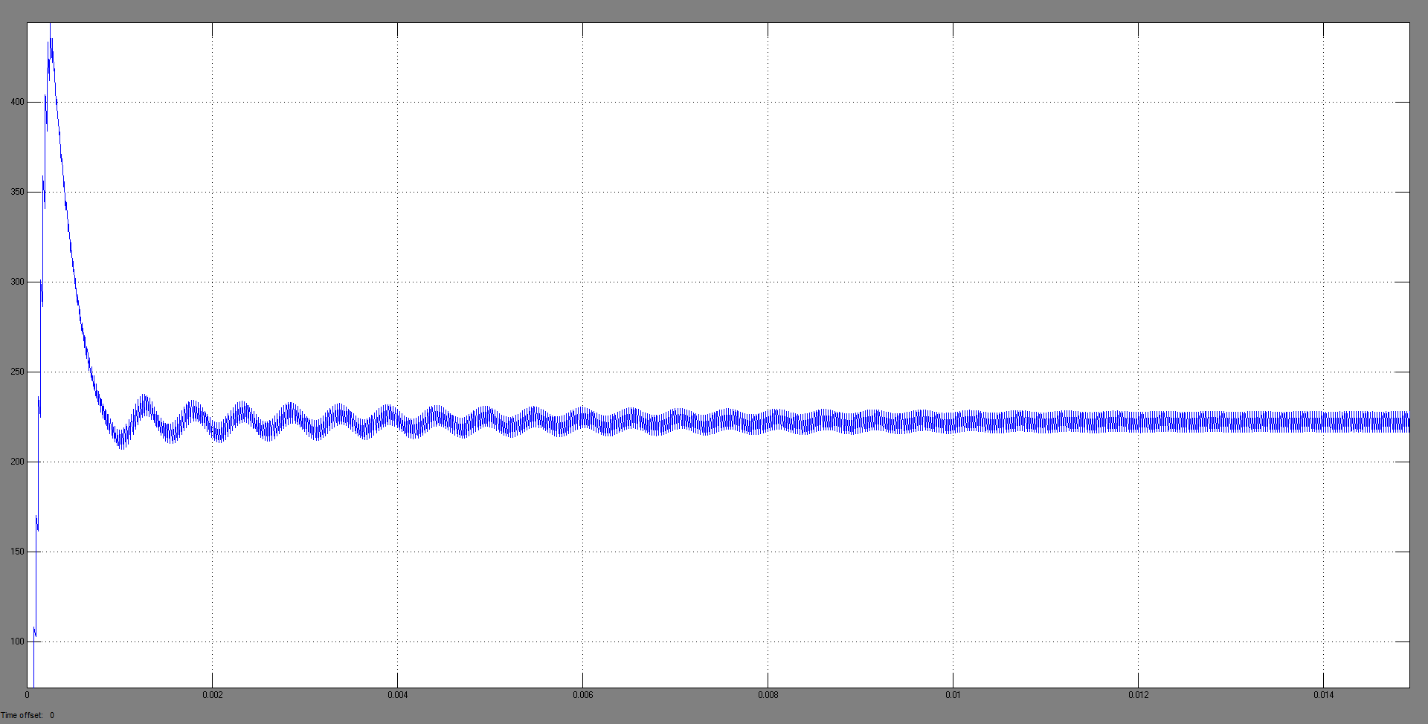

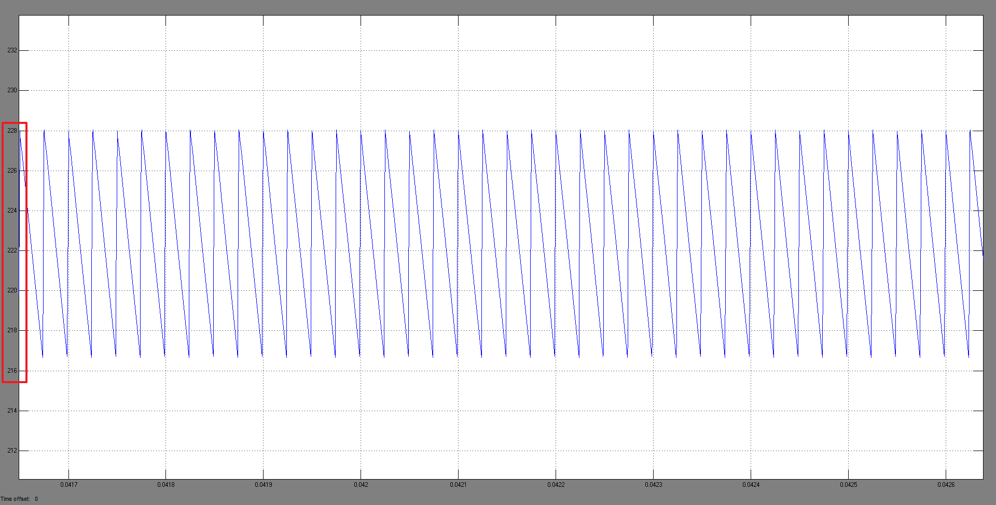



Apparently to control the , just adjust the C of the capacitor and the frequency of the switching.

1. **Non isolated switching power supply**

**Model:**

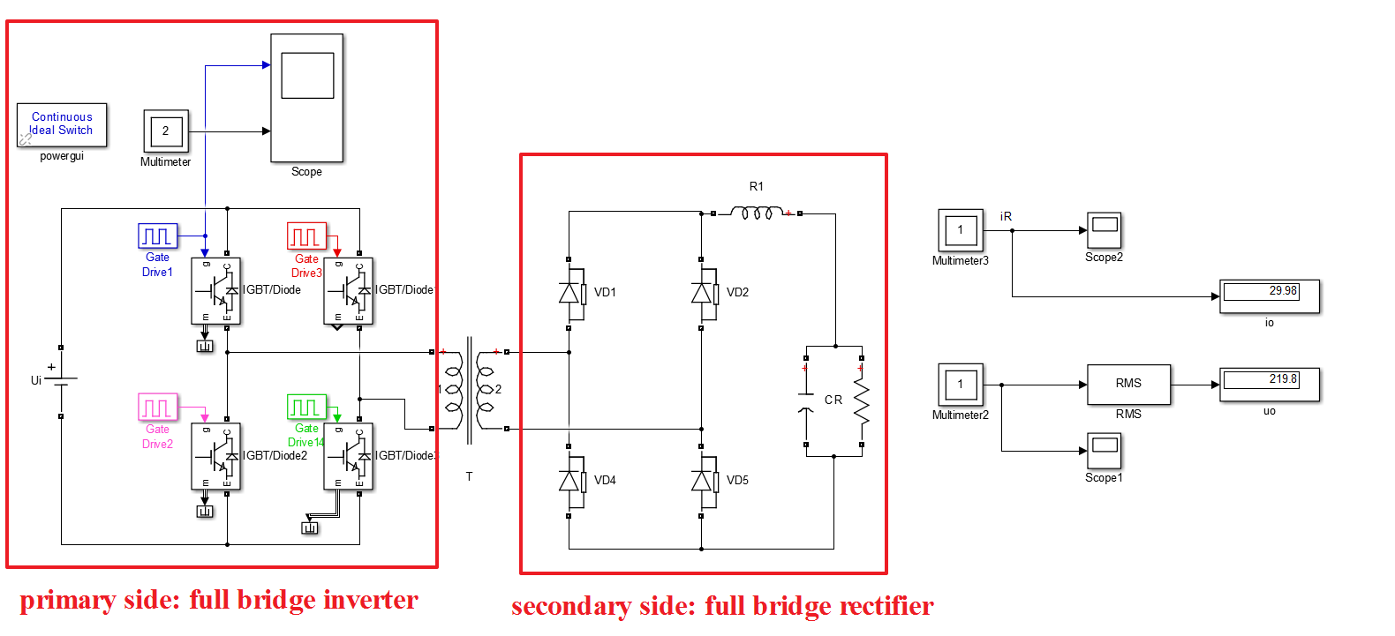

**Calculation and analysis:**

占空比啥的

各个参数怎么来的

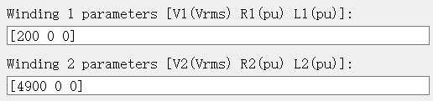

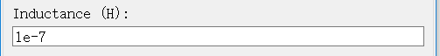



**Simulation**

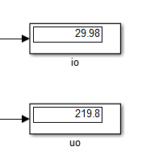

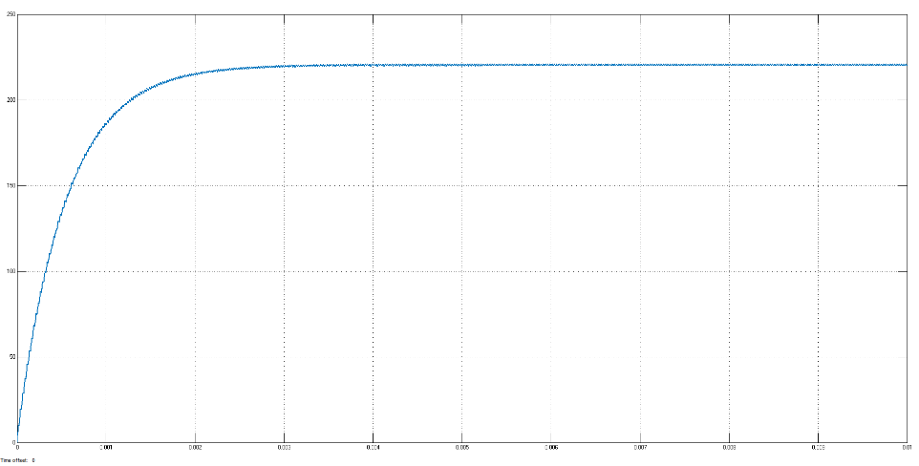

current

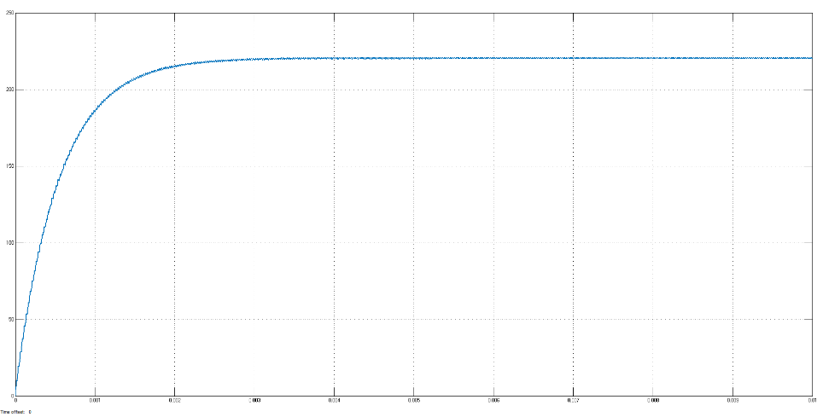

voltage

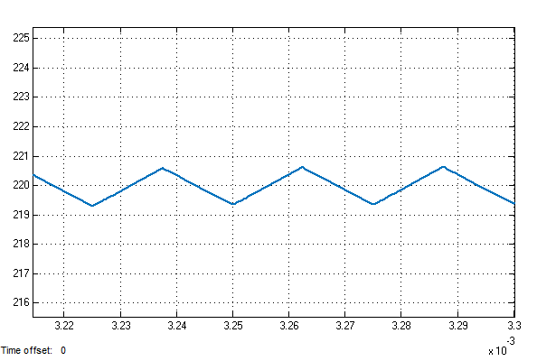 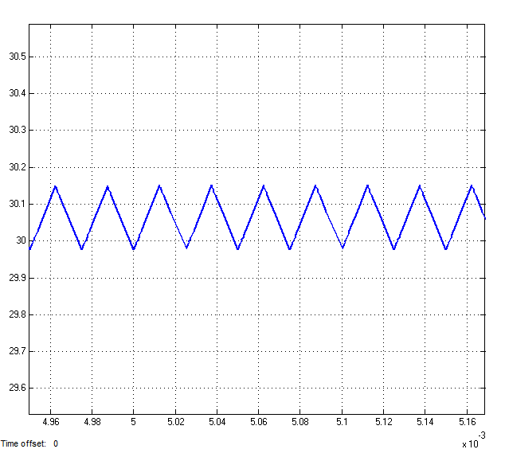



**Comparison:**

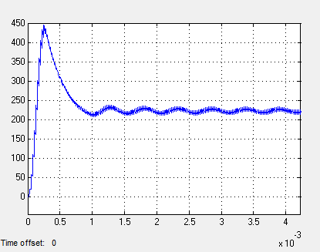 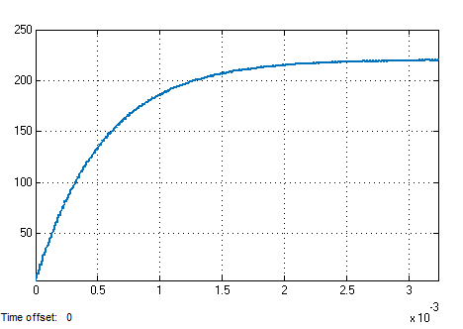

超调量和纹波系数…

所以第二种更稳定，动态性能更好